**SOLUTION DESIGN DOCUMENT**

**Coupa-Virtual Assistant Chatbot**

Version v2.0

|  |  |  |  |
| --- | --- | --- | --- |
| Date Issued | Version | Description | Author |
| 23/03/2025 | V1.0 | SDD | Ravi Teja Ragam & Suranjana Chowdhury |
| 09/04/2025 | V2.0 | SDD | Suranjana Chowdhury |
|  |  |  |  |

Table of Contents

Revision History 1

Distribution 3

1 Introduction 4

1.1 Overview 4

1.1.1 Business Requirement 4

1.1.2 Process Description 4

1.1.3 Features of Chatbot 4

1.2 Proposed Solution 4

1.3 Scope 5

2 Contacts 5

3 Prerequisites 5

4 Architecture 6

4.1 Overview 6

4.1.1 Copilot Studio Configurations 6

4.1.2 Communication Channels 6

4.1.3 Chatbot Interface 6

4.1.4 Auto Ticket Creation in ServiceNow 6

4.2 Flow Diagram 7

4.3 Architecture Diagram 8

4.4 Functionalities of ChatBOT………………………………………………………………………………………………………8-10

5 Solution Components 10

5.1 Create the Copilot using Microsoft Copilot Studio 11

5.2 Train the Created Copilot with the Required Data 12

5.3 Create the Topics in Copilot 13

5.4 Auto Ticket Creation in Service Now………………………………………………………………………………………13-15

6 Security 13

6.1 Risks and Mitigation 16

6.2 License Estimation 16

6.3 Triggers 16

7.Exceptions………………………………………………………………………………………………………………………………………17

7.1 Business Exceptions………………………………………………………………………………………………………………………….17

7.2 Technical Exceptions……………………………………………………………………………………………………………….17

# Distribution

The information has restricted distribution and viewing within Chanel.

Document Version Control

|  |  |  |  |
| --- | --- | --- | --- |
| Date Issued | Version | Description | Author |
| 23/03/2025 | V1.0 | SDD | Ravi Teja Ragam & Suranjana Chowdhury |
| 09/04/2025 | V2.0 | SDD | Suranjana Chowdhury |
|  |  |  |  |

Document Sign-off Requirements (NA)

The following table contains the people required to sign-off and/or review this document and those that require the document for information only.

|  |  |  |
| --- | --- | --- |
| Name | Department | Responsibility |
| Balagopal Madhusoodhanan | Power Platform | Principal Architect |
|  |  |  |
|  |  |  |

# 1 Introduction

## 1.1 Overview

### 1.1.1 Business Requirement

Managing diverse user queries manually across **multiple markets** resulted in inconsistencies, and an increased operational workload. To address this, the business sought an **automated, intelligent Chatbot solution** integrated into the **Coupa website**. This Chatbot ensures **instant, accurate, and market-specific responses** by leveraging a structured knowledgebase.

If a query cannot be resolved through the Chatbot, the **Chatbot facilitates ticket creation in ServiceNow**, ensuring seamless issue resolution while minimizing manual intervention. Additionally, the Chatbot would log unanswered queries and collects feedback for continuous improvement.

### 1.1.2 Process Description

As part of this automation, the Coupa Chatbot will assist users in addressing their queries efficiently. Users can interact with the Chatbot to seek answers from a structured knowledgebase based on their selected market and query type. If the Chatbot is unable to provide a satisfactory response or if the required information is not available, it will initiate an auto ticket creation in ServiceNow.

### 1.1.3 Features of Chatbot

* **Market-Specific Responses**: Provides **tailored responses** based on **market-specific** requirements.
* **Predefined & Free-Text Queries:** Users can choose from a structured set of **predefined questions** or input **free-text queries**.
* **Auto Ticket Creation in ServiceNow:** If query cannot be resolved, the Chatbot automatically creates a ServiceNow ticket, ensuring timely follow-ups.
* **Feedback Mechanism for Continuous Improvement:** Users can provide feedback on responses.
* **Automation & Efficiency:** Reduces **manual intervention**, speeds up response times, and enhances user experience.

**1.2 Proposed Solution**

To enhance query resolution and streamline support, the Coupa Chatbot Is integrated into the Coupa website, providing instant, market-specific responses through a structured knowledge base. It efficiently manages both predefined and free-text queries, minimizing manual effort and ensuring accurate responses.

Users have the option to ask for the ticket for any query in ServiceNow. When the BOT couldn’t answer any question/user is not satisfied with the response, automatic ticket creation is facilitated through the chatbot.

This solution boosts efficiency, scalability, and user experience while optimizing ticket management and query handling across multiple markets.

## 1.3 Scope

* Region: Europe
* Staff: Coupa
* Data Files: COUPA USER GUIDANCE & TOOLKIT UK

# 2 Contacts

|  |  |  |
| --- | --- | --- |
| Key Contacts | Email ID | Role |
| Suranjana Chowdhury | suranjana.chowdhury@chanel.com | Phoenix Power Platform Senior Developer/SD |
| Ravi Teja, Ragam | ragam.ravi-teja@chanel.com | Phoenix Power Platform Developer |

# 3 Pre-Requisites

|  |  |  |  |
| --- | --- | --- | --- |
| **Sr No.** | **Application** | **Platform** | **Access Type / Permissions Required** |
| 1 | Service Account accessibility to power automate flow | Power Platform | Premium |
| 2 | L_P_CORPO_CoupaBOT_DEV & L_P_CORPO_CoupaBOT_PROD  environment accessibility | Power Platform |  |
| 3 | Office 365 account linked with service account aa-coupa-chatbot | Office 365 |  |
| 4 | Access of service account to production environment & copilot studio license | Copilot Studio | Premium |
| 5 | Premium Connectors like Office 365, HTTP, respond to copilot  Availability in dev and prod environment | Copilot Studio | Premium |
| 6 | Azure Resource Group access for logging custom event | Azure |  |

# 4 Architecture

## 4.1 Overview

The architecture of the Coupa Chatbot is built on Microsoft Copilot Studio, ensuring a structured and intelligent approach to query resolution. The Chatbot interacts with the users via the Coupa website, process their queries using knowledgebase, and provide accurate responses. The solution incorporates the following key components:

### 4.1.1 Copilot Studio Configurations

The Chatbot is configured in **Microsoft Copilot Studio**, which defines the conversational flow. Copilot Studio enables the creation of dynamic workflows, ensuring that the Chatbot can efficiently handle various types of queries, including dissatisfaction triggers.

### 4.1.2 Communication Channels

The Chatbot is seamlessly integrated into the **Coupa website**, providing users with an intuitive interface to access support. This web-based deployment ensures easy accessibility while allowing real-time query resolution without switching between multiple applications.

### 4.1.3 Chatbot Interface

Users interact with the **Chatbot through the Coupa website**, where they can submit predefined or free-text queries. The Chatbot retrieves relevant responses from a knowledgebase and presents the most appropriate answer to the user.

### 4.1.4 Auto Ticket Creation in ServiceNow

When query cannot be resolved, the **Chatbot automatically initiates ticket creation in ServiceNow**.

## 4.2 Flow Diagram

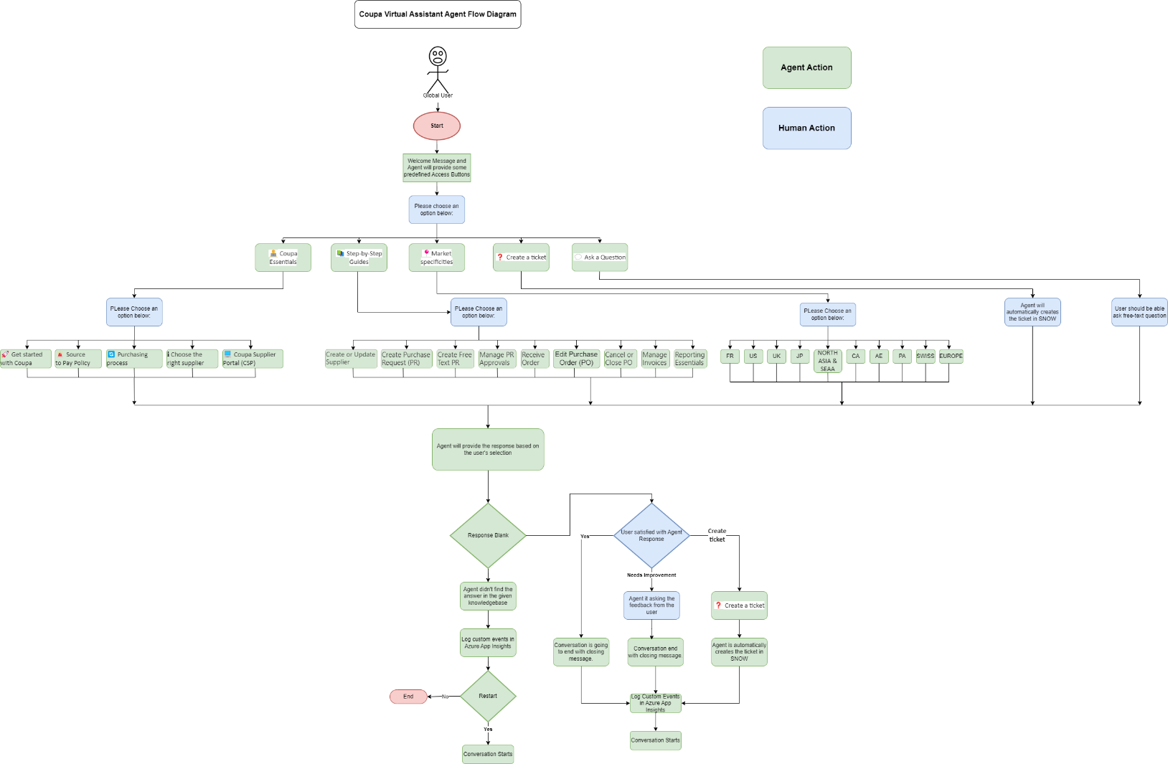

**Diagram 1.0**: Flow Diagram for Coupa Virtual Assistant Chatbot.



### 4.3 Architecture Diagram:

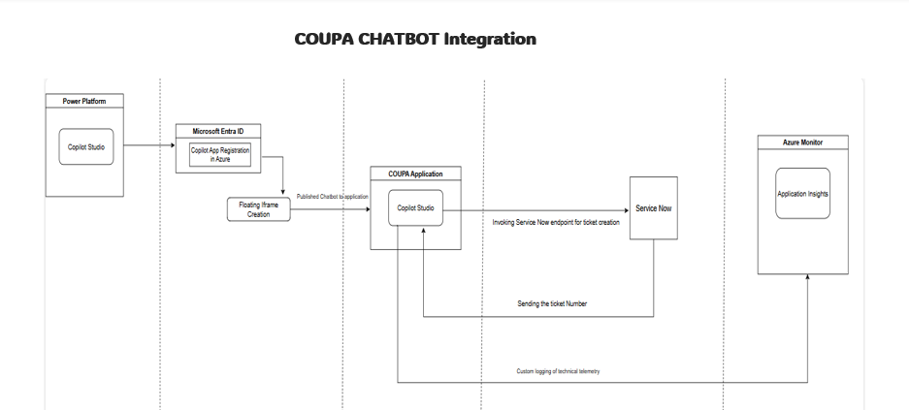

## Functionalities of ChatBOT

**1. Initial Interaction**

* 1. **Welcome Message**:
* The chatbot greets the user and presents some predefined access buttons:
* 🧑‍💻**Coupa Essentials**: For queries related to Coupa Essentials
* **📚 Step-by-Step Guides​:** For queries related to Step-by-Step Guides
* **📍Market specificities:** For queries related to market specificities.
* **❓ Create a ticket​:** For Auto ticket creation in SNOW.
* **💬 Ask a Question:** For free-text related queries.

**2. Sub Access Buttons Selection**

**2.**1 If user selects **Coupa Essentials**, Chatbot will provide some access buttons related to **Coupa Essentials**.

1. **🚀 Get started with Coupa**
2. **🚨 Source to Pay Policy**
3. **🔄 Purchasing process**
4. **ℹ️ Choose the right supplier**
5. **💻 Coupa Supplier Portal (CSP)**

**2.2** If user selects **Step-by-Step Guides**

1. **Create or Update Supplier**
2. **Create Purchase Request (PR)**
3. **Create Free Text PR**
4. **Manage PR Approvals**
5. **Receive Order**
6. **Edit Purchase Order (PO)**
7. **Cancel or Close PO**
8. **Manage Invoices**
9. **Reporting Essentials**

**2.3** If user selects **Market Specificities**

1. **FR**
2. **US**
3. **UK**
4. **JP**
5. **NORTH ASIA & SEAA**
6. **CA**
7. **AE**
8. **PA**
9. **SWISS**
10. **EUROPE**

**2.4** If user selects **Create a ticket**

1. **The Chatbot will automatically create a ticket in SNOW.**

**2.5** If user selects **Asks a Question**

1. **The user should be able to ask anything, or free text related to Coupa User Guidance and Kit.**

**3. Access Buttons Query Interaction Process**

**3.1 Access Buttons Response from the Chatbot.**

* Once the user selects any Access Buttons, the Chatbot will provide the corresponding response from the given knowledgebase.
  + If no response is found:
    - The Chatbot will display the message:  
      **"Thank you for your query. I did not find any answer for the selected Button."**
    - The Chatbot will offer the option to restart the conversation.
    - A log entry will be created in Azure Application Insights with relevant details (such as user’s question, response, and timestamp).

**3.2 Validating the Chatbot response with the user**

* **If a response is found:**
  + The Chatbot will ask the user**: "** **Did this answer meet your needs?" with three Options Yes, Needs Improvement, Create a ticket**
    - **If the user selects Yes:**
      * The Chatbot will send the closing message and ends the conversation and again restarts the conversation.
    - **If the user answers Needs Improvement:**
      * The Chatbot will ask to provide the feedback comments.
      * Once the user provides feedback, then Chatbot is going to end current conversation and again it restarts the conversation.
    - **If the user answers Create a ticket:**
      * The Chatbot will automatically create the ticket in SNOW.
      * It will send the message like the below:  
        “  
        **You will receive an email notification once your ticket is created. You can track it or add someone to the watchlist directly in ServiceNow/United.**”
      * The chatbot will also send the closing message and restart the conversation.

**3.3 Log Data in Azure Application Insights**

* Every interaction (including no-response scenarios, user feedback, and the final conversation details) will be logged in Azure Application Insights, capturing:
  + **Query that could not be answered (Question [short Description] & Ticket Number)**
  + **Questions for which response was not satisfied (Question [short Description] & Ticket Number)**
  + **Questions for which only ticket is created (Question [short Description] & Ticket Number)**
  + **User’s feedback comments (if provided)**
  + **User’s time zone**
  + **All questions.**

**3.4 Reporting**

* + **Most frequently asked questions in a month (Reporting to be done per month)**
  + **Number of Interactions (Reporting to be done per month)**

# 5 Solution Components

## 5.1 Create the Copilot using Microsoft Copilot Studio

* Initially, create the Copilot by providing the Name, Icon, Description and Instructions of the Copilot in Overview Tab and then click on save button.

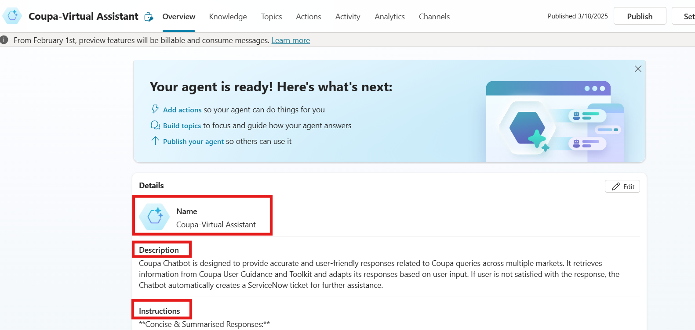

***Fig: Basic Required things for the Copilot in Microsoft Copilot Studio***

## 5.2 Train the Created Copilot with the Required Data

* Once Overview is completed, Add the Knowledge in Knowledge Tab. Train the Copilot with the necessary data to ensure it provides accurate and relevant responses to user queries.
* After clicking the Add Knowledge tab, we can add knowledgebase from different sources like Public Website or SharePoint or Dataverse ...etc. based on the requirement.  
  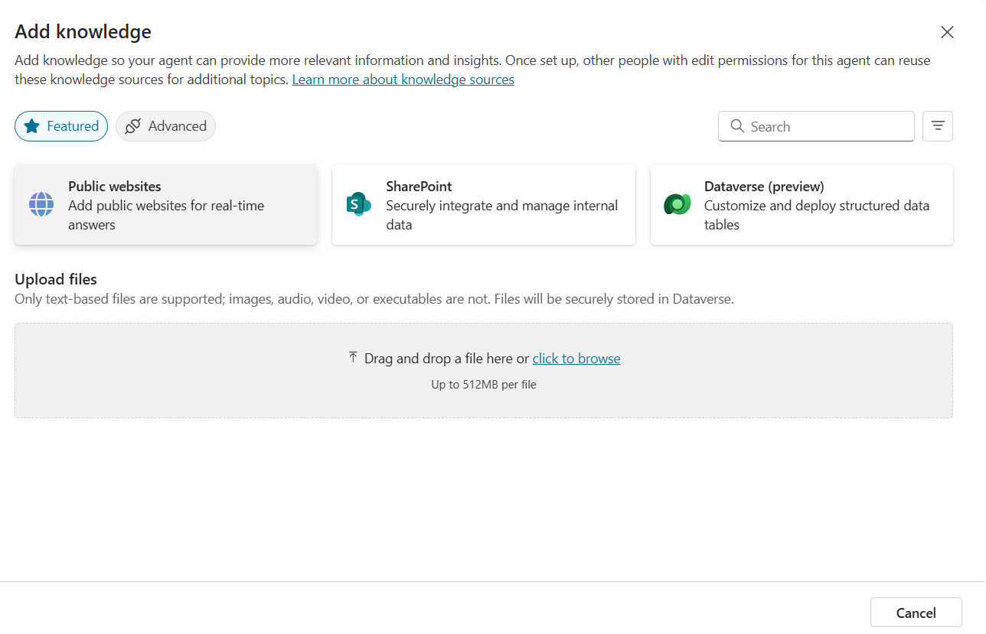

**Fig: Adding the Knowledgebases to the Chatbot**

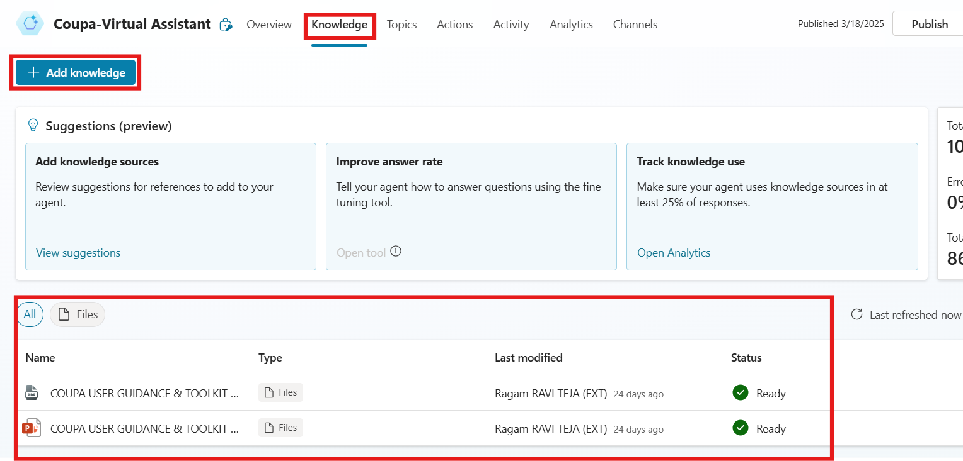

***Fig: Added some Knowledge for this Copilot***

## 5.3 Create the Topics in Copilot

* After Knowledge, add the topic for the Copilot. In the topics section, we have system topics and Custom topics. We can create our topics based on our requirements.

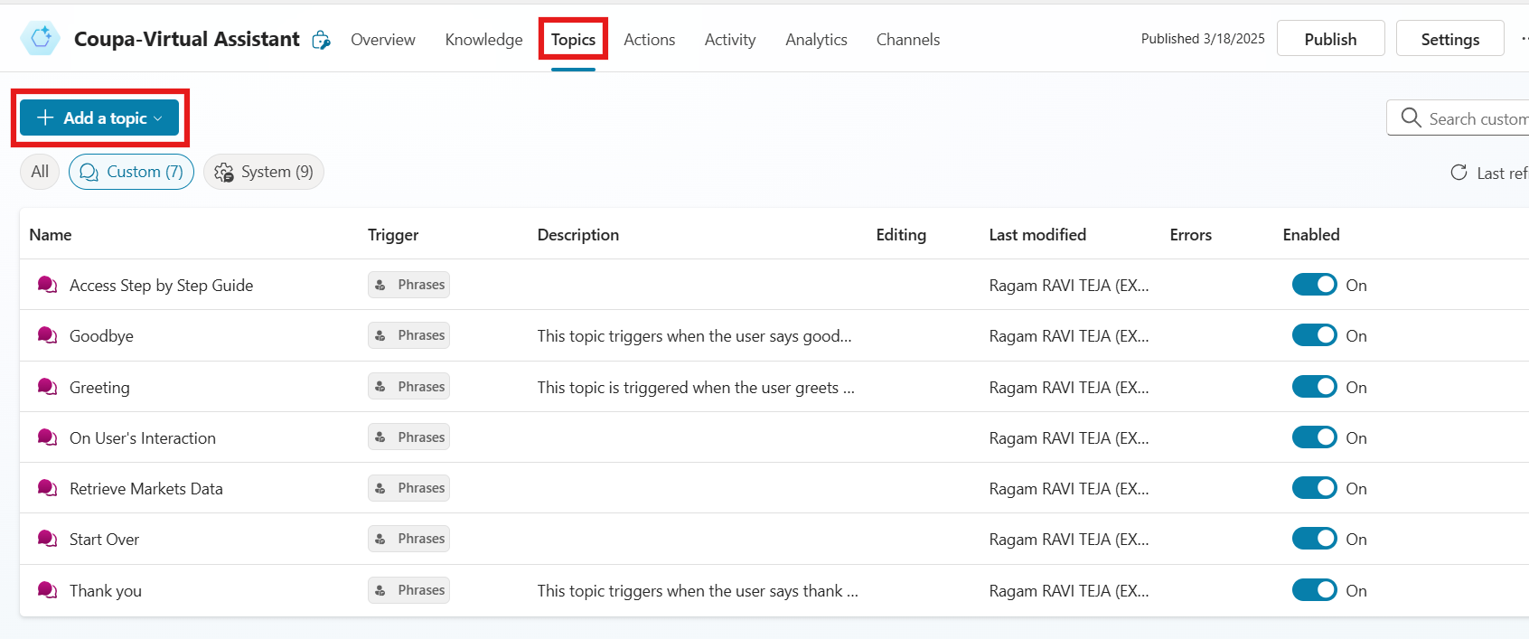

***Fig: Copilot Topics in Microsoft Copilot Studio***

***5.4* One Pager link to the document and Screenshots**

* The Chatbot is giving the one pager link for the document where the Chatbot has given the answer from the knowledgebase. So that, user can check the document***.***
* *Along with the response if there are screenshots available in the knowledgebase, the Chatbot is providing the images as well after the response.*

***Fig: One Pager link for the document for User Reference***

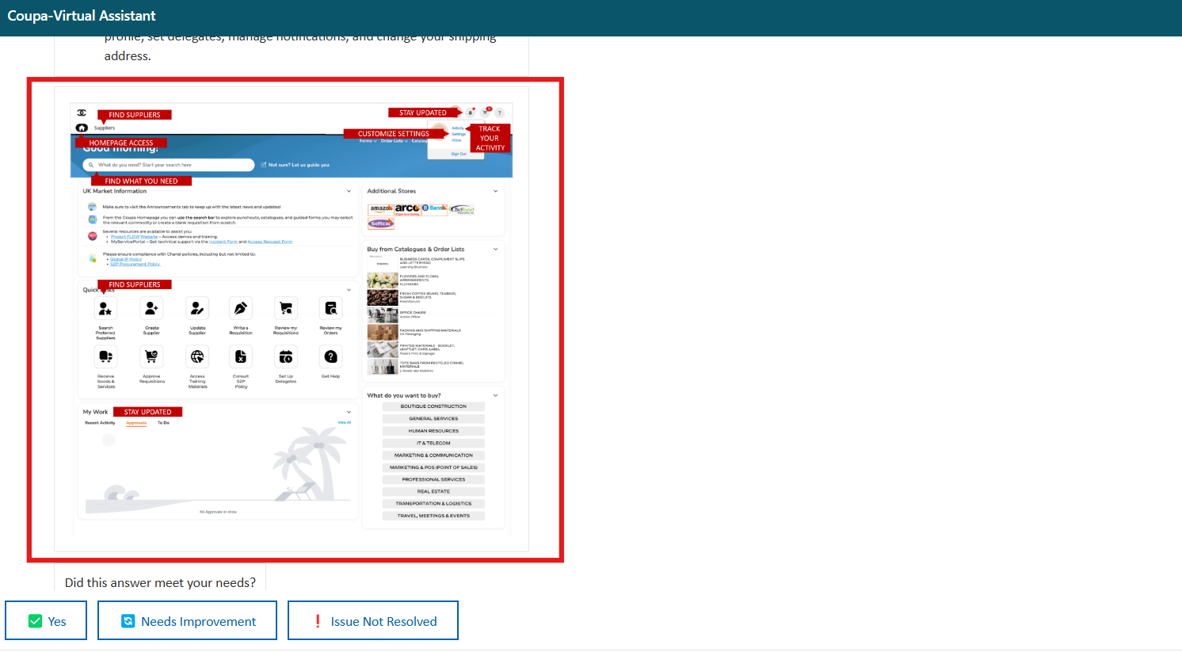

***Fig: Screenshot is added along with the response***

***5.5 Auto Ticket Creation in Service Now***

Service Now API: <https://ccunited.service-now.com/api/sapim/genericintegration/inboundpost>

Form Link: <https://ccunited.service-now.com/myserviceportal?id=sc_cat_item&sys_id=97fe9c28db462410bcc0cbb30596199d>

Ticket: INC1584608

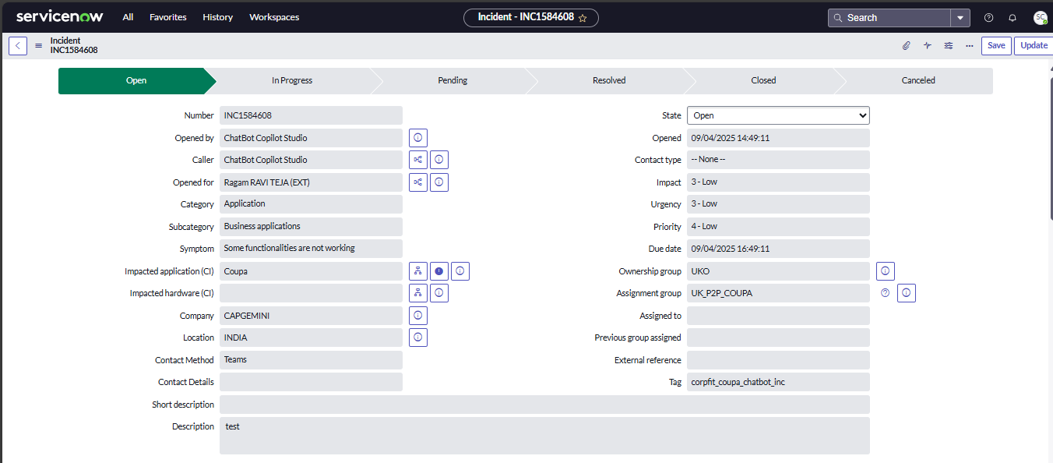

**Payload:**

{

"Opened for": "User AD ID",

"tag": “corpfit_coupa_chatbot_inc”

"Category": “application",

"Subcategory": “business application”,

"Impacted application": "Coupa",

"Scope": "Based on Market",

"Symptom": "some functionalities are not working”,

"On which hardware or device are you facing the issue (computer, mobile phone, tablet, printer, ...)?": “Not mine”,

"Impacted hardware": "Blank”

"Description": " Description provided by user”

}

**FLOW:**

Coupa Chatbot || Auto Ticket Creation in ServiceNow – This flow will extract user AD ID, pass the details of payload to service now endpoint to create the ticket.

# 6 Security

*Only Coupa team is accessing the Chatbot*

## 6.1 Risks and Mitigation

The Chatbot would be deployed in COUPA application. Users having specific roles will be able to interact with the chatbot.

This Chatbot is integrated with the defined knowledgebase to give the required response.

Knowledge base Link:

<https://lpl.sharepoint.com/sites/ChanelS2PProgramme/Shared%20Documents/TRAINING/WHATFIX%20ONE%20PAGERS/COUPA%20USER%20GUIDANCE%20&%20TOOLKIT/PDF/COUPA%20USER%20GUIDANCE%20&%20TOOLKIT%20UK.pdf?CID=28fdb765-890d-4018-a007-80b38d0e5a6d#page=5>

## 6.2 License Estimation

Service account aa-coupa-chatbot created to deploy the flow in production.

Copilot studio license for the service account for production environment.

## 6.3 Triggers

When user asks a question to the Chatbot.

## 7. Exceptions

## 7.1 Business Exceptions

|  |  |  |
| --- | --- | --- |
| **Sno.** | **Exception Description** | **Next Steps post exception** |
| 1 | The Chatbot cannot find a relevant response to the user’s query due to missing knowledgebase content. | BOT will notify that knowledge base does not have required information and will create an incident. |
| 2 | User selects wrong market | BOT will answer the question depending on the market selection. |
| 3 | Wrong assignment group of an incident due to wrong selection of markets. | BOT will create the incident assigning to incorrect team/or will fail to create the ticket |

## 

## 7.2 Technical Exceptions

|  |  |  |
| --- | --- | --- |
| **Sno.** | **Exception Description** | **Next Steps post exception** |
| 1 | The Chatbot fails to create a ServiceNow ticket due to Power Automate issues or ServiceNow API downtime | BOT will send a mail notification to support team (RPA team) and it will ask user to create a ticket by providing the form link. |
| 2 | Any new customizations in ServiceNow form will lead to error while creating the ticket. | BOT will attempt to create an incident. However, if it fails to create one, it will ask user to create a ticket by providing the form link. |
| 3 | If any data loss prevention policy is enforced in the environment chatbot will give error during interactions. | DLP blocker must be removed, and the agent needs to be published again. |